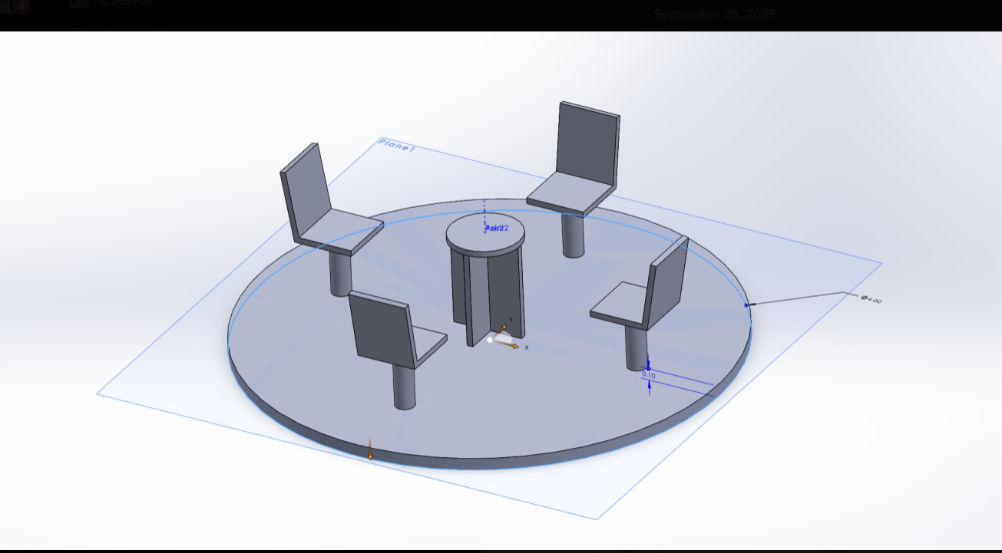Overview:
Using the image above as reference, we are looking to select ideal materials for our playground carousel. The criteria for the selection is that the materials must be safe, durable, cost effective, and hopefully easy to manipulate for assembly. Our carousel consists of a circular base plate with four seats on top that will be bearing a 200N load and a centripetal load when in use.

Material options:

Part | Material | Pros | Cons | Score  (0-10)
Base Plate | Carbon Steel  (AISI 1020) | - Stiff and tough for the price( E= 200 GPa)  - Easy to weld  - Simple fabrication  - Takes HDG (hot dip galvanization) and powder coat for a longer outdoor life | - Needs HDG and powder for corrosion protection  - Heavier that aluminum, harder to move/ install | 9
Base Plate | Aluminum Plate  (Aluminum 5052-H32) | - Lightweight  - Good corrosion resistance without coatings | - Lower stiffness ( 69 GPa) meaning we need a greater thickness  - Costlier p kg than steel  - Harder to weld | 5
Base Plate | Stainless steel Plate  (AISI 304/316) | - Very good corrosion resistance  - No need for paint (low maintenance)  - Good toughness and easy to weld | - Very expensive  - Heavier than carbon steel | 7
Seat post | Plain Carbon Steel  (AISI 1020) | - Great against buckling  - Very weldable  - Takes HDG (hot dip galvanization) and powder coat for a longer outdoor life | - Needs HDG and powder for corrosion protection  - Heavier that aluminum, harder to move/ instal | 9
Seat post | Stainless steel | - Very good corrosion resistance  - No need for paint (low maintenance)  - Good toughness and easy to weld | - Very expensive  - Heavier than carbon steel | 8
Seat post | Aluminum Tube (6061-T6) | - Lightweight | - Lower stiffness  - Needs thicker wall to meet buckling limit | 4
Seats | High Density Poly Ethalyne  (HDPE) | - Non-splintering  - Easily round edges  - Warm to touch  - UV/ weather resistant with no added paint  - High impact toughness  - Low maintenance  - inexpensive | - Lower stiffness vs metals  - Creep under high | 9
Seats | Phenolic Laminate  (HPL) | - Very stiff, thinner than HDPE for same feel  - Weather resistant without paint or coat | - Edges are harder  - Brittle compared to HDPE with sharp impacts  - More expensive than HDPE | 6
Seats | Aluminum  5052-H32 | - Lightweight  - Easy to pass ribs or beads for stiffness | - Hot to touch under sun  - Slippery unless textured  - Needs extra work around sharp edges  - High fabrication effort | 6
Floor | Aluminum 5052-H32 Tread (Checker) | - Great wet traction  - Corrosion resistant  - Lightweight | - Thermal comfort | 8
Floor | Fiberglass  (GFRP ) | - Excellent wet/dry traction  - Thermal comfort  - Good impact toughness | - Brittle edges  - UV topcoat  - higher cost compared to aluminum | 7

Materials:

Part | Material | Reason for Selection
Base Plate | Carbon Steel  (AISI 1020)
Seat post | Carbon Steel  (AISI 1020)
Seat | HDPE
Floor plate | Aluminum 5052-H32 Tread (Checker)

References:
- https://cemer.com/en/carousels
- https://www.miracle-recreation.com/blog/different-playground-equipment-surfaces/?lang=can
- Solidworks
- https://www.cpsc.gov/s3fs-public/325.pdf?utm_
- https://www.polymershapes.com/application/playground-equipment/

